1. **Problem Statement**

People of all kinds from around the world flock to London, UK with some of these them aspiring to make this remarkable place a home of their own. With varying budgets and needs, people find it very hard to find a suitable place and neighborhood to accommodate them and their families. Due to high cost of living and other multiple issues, London housing has been struggling. With the inevitable Brexit, the problem has further compounded. A potential client aspiring to buy a suitable property would like to become knowledgeable about the ongoing pricing to make a conscious decision. Further, he/ she would like to consider several factors like proximity to schools, medical care, restaurants to accommodate his/ her familial needs.

With government provided authentic data on London properties coupled with data science techniques, one can make derive the useful information about current pricing in different localities of London while considering other factors of his choice. This would help the potential client to make an informed decision about buying a suitable property.

**Target audience: -**

Potential clients looks to buy suitable property in London but are skeptical due to lack of knowledge and volatile market conditions.

**Stakeholders: -**

1. GovernmentofUK
2. Sellers
3. Buyers
4. Real estate agents

**2. Data Section**

Following sources of data are used while executing the Capstone Project: -

* **Data item: -**Open Data published by Government of UK under the section **HM Land Registry: Price Paid Data**

**Type of data: -**

Dataset in form of CSV file

**Duration: -**

August 2018 data

**Description of the dataset: -**

Price Paid Data includes information on all property sales in England and Wales that are sold for full market value and are lodged with them for registration.

The dataset includes the transactions received at HM Land Registry in the period from the first to the last day of August 2018.

This dataset was downloaded and later hosted on https://labs.cognitiveclass.ai/ for ease of use.

**Source: -**

http://landregistry.data.gov.uk/

* **Data item: -**Google Maps Geocoding API

**Type of data: -**

JSON

**Duration: -**

N/A

**Description of the data: -**

Location coordinates obtained by Gmaps API calls.

Location Information obtained from Price Paid Dataset is used to obtain the location coordinates from Google Maps.

A separate Python script has been developed to extract the unique street names, district names from the Price Paid Dataset and embed those in the GMaps API calls to obtain the required information.

**Source: -**

Google Cloud Platform/ Google Maps

• **Data item: -**Foursquare location data

**Type of data: -**

JSON

**Duration: -**

N/A

**Description of the data: -**

Location coordinates obtained by Foursquare API calls.

To determine the proximity of various amenities as per the client’s requirement, Foursquare location data is used.

**Source: -**

https://foursquare.com/

**3. Methodology**

Price Paid Dataset contains the sale prices of properties in England and Wales submitted to HM Land Registry for registration. This is an open dataset which is hosted on http://landregistry.data.gov.uk/. This data is updated monthly and is made available from 1995.

This project is focused on investigating the most recent market prices of Property in the city of London and recommend various locations where the prospective client can buy a property based upon his/ her budget.

The automated script developed as a part of this project does the following: -

1. Parsethenecessarydatafromthepricepaiddatasetwhichincludesthetransactions received at HM Land Registry in the period from the first to the last day of August 2018.
2. The data is cleansed and any data of sales agreements which predates 2016 is deleted from the dataset.
3. The data is further condensed by selecting it only for the city of London which is area of choice in this project.
4. Unique “Street names” in the city of London where recent transactions for sale of property were done are filtered from the dataset.
5. Location coordinates (latitude, longitude) of these street names are fetched by making API calls to Google Maps. A separate one-time Python script was developed to fetch this data and store it in a CSV file.
6. The average price of property on each of these streets is determined by taking a mean on recent transactions of sale of property on respective streets.
7. Based upon the budget of the client, the current average prices are compared and all recommendations for the locations are made by plotting them on map of London. The locations popups are labelled with the respective street names and their average property price.
8. The recommended locations are further fed into Foursquare API calls to determine various venues in proximity to them. All reported venues are then tabulated and presented to the user.
9. Important facilities like Hospitals, Grocery stores, Elementary schools, High Schools are searched in vicinity of each location and then reported in a tabular form to the user.

In order to conduct a similar analysis for any other city in UK or Wales, the automated script has been written to accommodate a change in: -

1. City/Town  
2. Budget of the client

Such changes can be made with minimal effort and would generate the recommended locations to buy a property in the city of choice.

**4. Results**

Upon running the exploratory data analysis for city of London with a hypothetical budget of GBP 2.2 Million – GBP 2.5 Million, the machine learning algorithm recommends 39 streets in London where the prospective client can choose to buy the property as per the current market prices.

A list of such locations is presented to the user with location coordinates and most recent average prices.

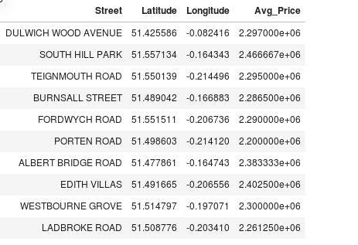

These recommended street names are plotted on the map of London with the average market prices.

Further, following venues are enlisted for the user to make an informed decision while choosing a location.

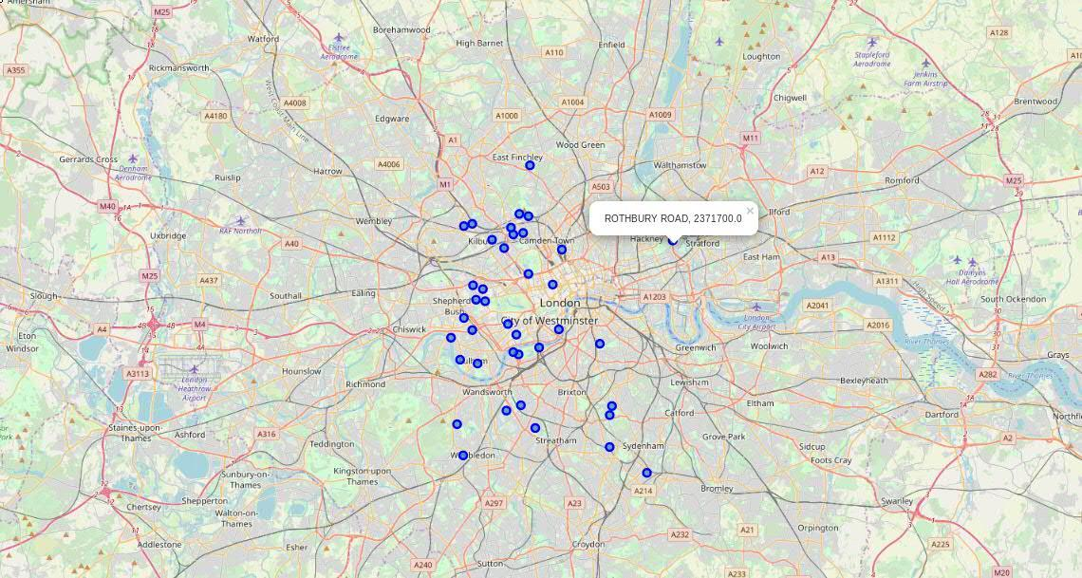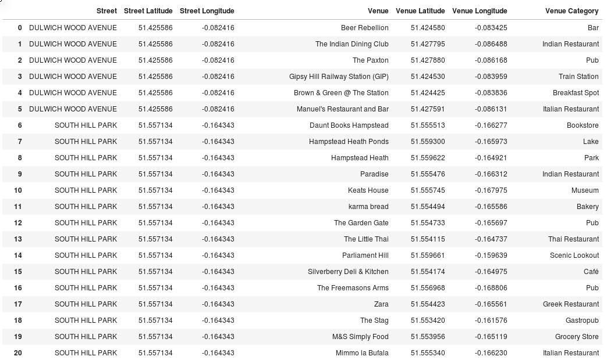

Important facilities are also presented to the user in a tabulated format to take care of his familial needs.

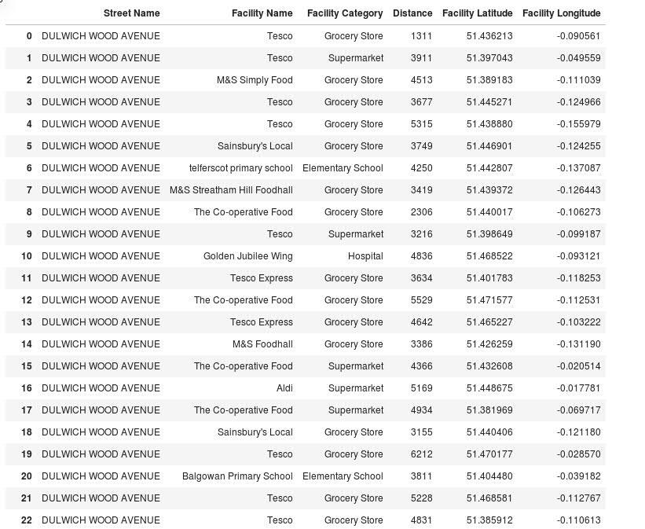

**5. Discussion**

Based upon the findings in the results section, the user can take a conscious decision about choosing a street/ location based upon his/ her requirements.

The results section enlists 39 places where a prospective client can buy a property based upon his needs and choices. Such choices would be affected by the venues and facilities which are close to the property which match against his familial needs.

Few possible cases are: -

1. A prospective client with elders in the family would be inclined to choose a location where hospitals and grocery stores are located in close proximity.
2. A prospective client with kids in the family would choose a location where elementary and high schools are close-by. He would also like to choose a place with parks and other venues to accommodate his family are in the close vicinity.
3. A bachelor would be inclined to choose a property which has pubs, bars, entertainment places close to the property.

**6. Conclusion**

The decision of a buyer is influenced by the familial needs, personal biases. So, based upon the findings summarized in the results and discussion sections, following conclusions can be made: -

1. While making recommendations to a prospective client, it is imperative to know his/ her immediate needs and requirements besides the budget. This would help to catch his/ her attention.
2. Knowledge about the most recent market prices can be very helpful for the client and can help him take a decision.